SCIENCE CLASS TEST
CLASSIFICATION OF PLANTS
Full marks-15

- Choose the correct option - (5 marks)

- This feature makes the shrubs different from trees
  - Branches arise near the base of shrubs.
  - Shrubs cannot stand upright.
  - Shrubs have green, woody stem.
  - Shrubs are annual plants.
- Assertion (A): Plants that grow in desert have leaves reduced into spines.
Reason (R): Plants release a lot of water into the air through the process of transpiration.
  - Both A and R are true and R is the correct explanation of A.
  - Both A and R are true and R is not the correct explanation of A.
  - A is true but R is false.
  - Both A and R are false.
- Assertion (A): Gymnosperms produce fruits by pollination.
Reason (R): They bear attractive flowers which produce nectar.
  - Both A and R are true and R is the correct explanation of A.
  - Both A and R are true and R is not the correct explanation of A.
  - A is true but R is false.
  - Both A and R are false.
- Observe the given image carefully.
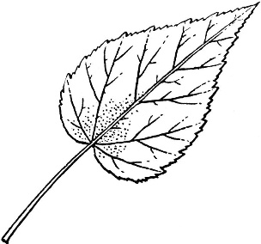
Statement 1- This plant has dicot seed.
Statement 2- This plant has fibrous root.
- Statement 1 is correct but statement 2 is incorrect.
- Statement 2 is correct but statement 1 is correct.
- Both the statements are correct.
- Both the statements are incorrect.
- Statement 1: Thalophytes are primitive plants.
Statement 2: They can survive in moist environment.
  - Statement 1 is correct but statement 2 is incorrect.
  - Statement 2 is correct but statement 1 is correct.
  - Both the statements are correct.
  - Both the statements are incorrect.

- Subjective questions- (10 marks)

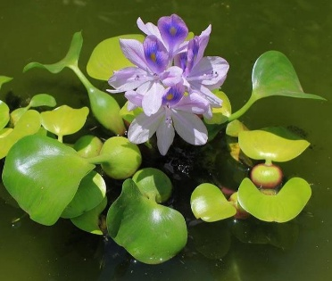
- Observe the given image and answer the following questions –
- In which group can you classify this plant? (1)
ii. Write 2 features that help them to survive in this habitat. (2)
7. X and Y are two plants with green stems. X can grow vertically upwards but Y cannot do so on its own and requires an additional support.
i. Identify X and Y as herbs, shrubs, trees, creepers or climbers. (1)
ii. Mention one point of difference between Y and a creeper. (1)
8. Complete the given analogy. (1x2)
i. Rice : __ root :: Carrot : tap roots
ii. Algae : Thalophytes :: Cactus : ___
9. With the help of appropriate diagrams, highlight the difference in characteristics features of tap root and fibrous roots. (3)

